Chapter 3

**PROPOSED WORK (DIGITAL LCC)**

**3.1 Overall system**

Overall system of Digital LCC.

Cloud

Cloud

Farmer

 Smart Device

 Delusion Tree

 Average RGB

Simple Segmentation

 Result

Complex segmentation

Cloud Processing

 Keras Model

 Result

Figure 3.1: Overview of Digital LCC

**3.2 Dataflow Diagram**

Dataflow diagram of Digital LCC.

.

Cloud

Field Area

Field Area

Offline

Avg Green

Avg Red

Avg Blue

Time

Tine

Rect area

Decision tree depth 5

70% Green Shade

120*80*4 Array

Farmer

Input

Output Fertilizer

Online

Leaf on hand Image

Input

Send to Cloud

Segmentation

Feed in Keras model

Predict the closest label

Input and label calculation

Output fertilizer

Figure 3.2:Dataflow diagram of Digital LCC

**3.3 Ideal Data**

Ideal data was capture using Webcam (Logitech C920). The webcam has stand on a tripod for capturing data. Webcam captured data at different lighting condition in shade from 9AM to 1:30PM.

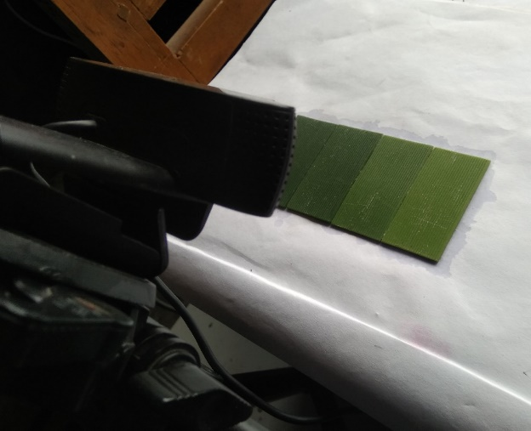

Figure 3.3:Ideal data collection using webcam

Code used for capturing image:

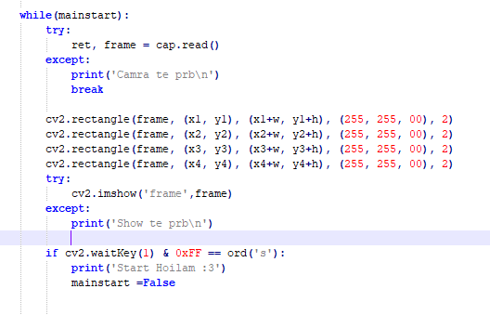

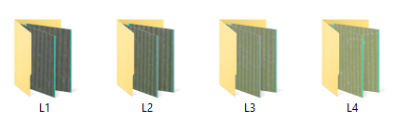

Figure 3.4: Ideal data sets

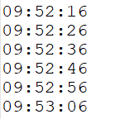

Figure 3.5: Ideal data sets time

**3.4 Data Collection (Paddy Fields)**

Capturing leaf image using smart phone (Samsung Galaxy Note 5, Samsung J7, Symphony P7) in the field and writing note of label matching LCC manually.

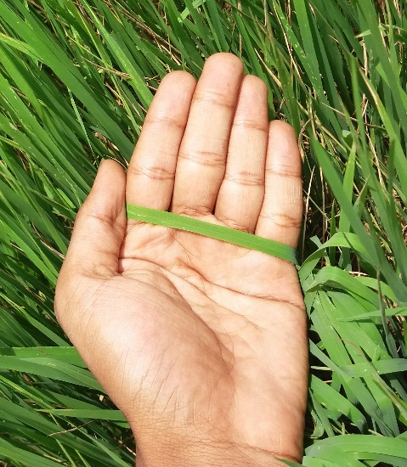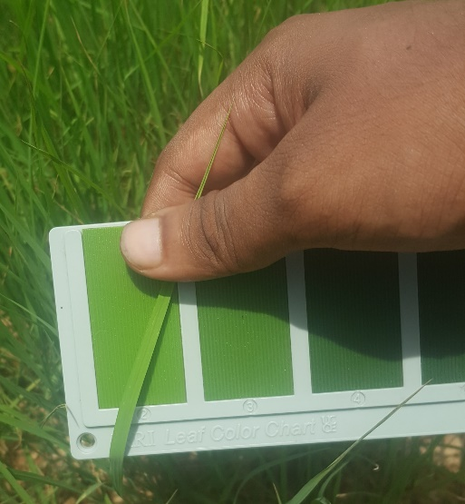

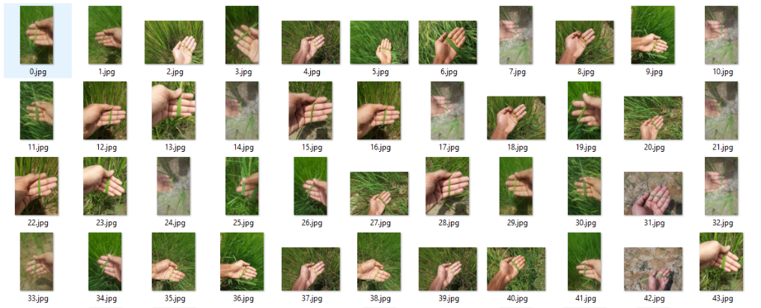

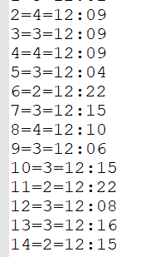

Figure 3.6: Paddy field data collection with time

Total 150 image was captured for testing without LCC in the image with capture time.